**Multimodal Acoustic Trap Display**

# MEMBERS

Ryuji, Diego, Sri

# DESCRIPTION

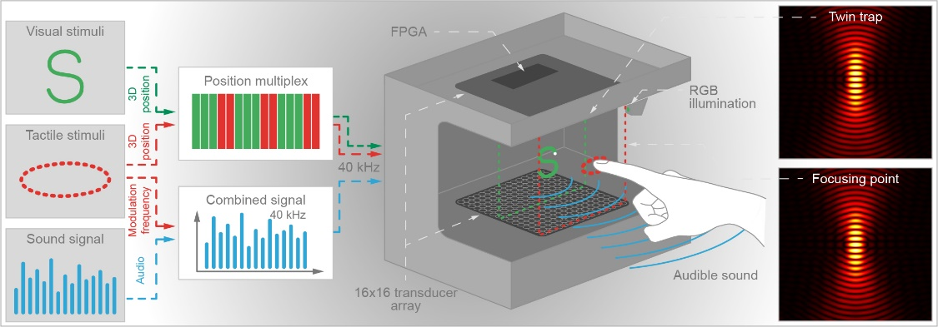

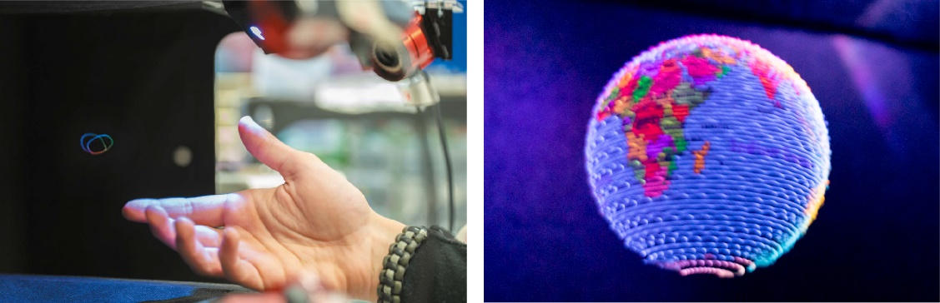

At the Interact Lab, we developed the Multimodal Acoustic Trap Display (MATD) to create 3D content that we can directly see, hear and touch, like holograms portrayed in popular science-fiction movies. The MATD makes use of ultrasound to trap, quickly move and colour a small particle in mid-air, to create coloured volumetric shapes visible to our naked eyes (like old CRT televisions). Making use of the pressure delivered by the ultrasound waves, the MATD can also create points of high pressure that our bare hands can feel and induce air vibrations that create audible sound.

As the MATD can create multimodal (visual, audio and tactile) 3D content without the need for VR headsets as well as other devices (e.g. headphones, controllers and data-gloves), it has a potential to be used in a lot of fields including entertainment, advertising, communication, education and medical. We are now working on various challenges to extend the capabilities of the MATD for the practical applications.

# VIDEO

<https://www.youtube.com/watch?v=Tm8JRlJ1q50>

# PUBLICATION

Ryuji Hirayama, Diego Martinez Plasencia, Nobuyuki Masuda, Sriram Subramanian, A volumetric display for visual, tactile and audio presentation using acoustic trapping, Nature 575, 320–323 (2019)  
<https://www.nature.com/articles/s41586-019-1739-5>